**COURSE : ARTIFICIAL INTELLIGENCE**

**TITLE: CREATE A CHATBOT IN PYTHON**

**PHASE 2 SUBMISSION**

**TEAM MEMBERS:**

**SRIVALSAN. S (au311521106098)**

**VALLARASU . S (au3115211060107)**

**INTODUCTION:**

In an increasingly digital world, the demand for intelligent and interactive conversational agents has surged. Chatbots, driven by the power of natural language processing and artificial intelligence, have become indispensable tools for businesses and individuals alike. This project aims to address this growing need by developing a Python-based chatbot capable of engaging users in text-based conversations on a wide array of topics. This chatbot is designed to provide information, answer questions, and offer assistance in a manner that mimics human interaction, making it a valuable asset for customer support, information retrieval, and general conversational purposes. By harnessing the capabilities of modern AI and natural language understanding, this chatbot will not only streamline communication but also enhance the user experience, ultimately becoming a valuable addition to any platform or service.



**DATA SET LINK:**[**https://www.kaggle.com/datasets/grafstor/simple-dialogs-for-chatbot**](https://www.kaggle.com/datasets/grafstor/simple-dialogs-for-chatbot)

**DATA SET:**

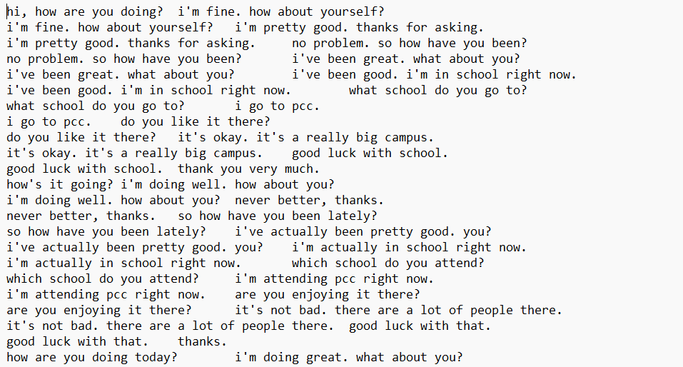

PROGRAM:

import numpy as np

import string

from nltk.corpus import stopwords

import pandas as pd

from sklearn.feature_extraction.text import CountVectorizer

from sklearn.tree import DecisionTreeClassifier

from sklearn.feature_extraction.text import TfidfTransformer,TfidfVectorizer

from sklearn.pipeline import Pipeline

df pd.read_csv('../input/simple-dialogs-for-chatbot/dialogs.txt',sep='**\t**')

a = pd.Series(df.columns)

df

a = a.rename({0: df.columns[0],1: df.columns[1]})

b = {'Questions':'Hi','Answers':'hello'}

c = {'Questions':'Hello','Answers':'hi'}

d= {'Questions':'how are you','Answers':"i'm fine. how about yourself?"}

e= {'Questions':'how are you doing','Answers':"i'm fine. how about yourself?"}

df = df.append(a,ignore_index=True)

df.columns=['Questions','Answers']

df = df.append([b,c,d,e],ignore_index=True)

Df

df = df.append(c,ignore_index=True)

df = df.append(d,ignore_index=True)

df

def cleaner(x):

    return [a for a **in** (''.join([a for a **in** x if a **not** **in** string.punctuation])).lower().split()]

Pipe = Pipeline([

    ('bow',CountVectorizer(analyzer=cleaner)),

    ('tfidf',TfidfTransformer()),

    ('classifier',DecisionTreeClassifier())

])

Pipe.fit(df['Questions'],df['Answers'])

Pipe.fit(df['Questions'],df['Answers'])

Pipe.predict(['how are you'])[0]

Pipe.predict(['great'])[0]

Pipe.predict(['What are you doing'])[0]

**OUTPUT:**

Pipeline(steps=[('bow',

                 CountVectorizer(analyzer=<function cleaner at 0x7f5cfaae40e0>)),

                ('tfidf', TfidfTransformer()),

                ('classifier', DecisionTree

'hello'

"i'm fine. how about yourself?"

'i appreciate that.'

"i'm going to change the light bulb. it burnt